Chapter 6

Data Science and Big Data
Over the last decade, there has been a lot of hype about data science and big data. The hype has resulted in much excitement and has encouraged many students, researchers, academicians, and organizations to get interested in this subject. Organizations have become interested in using data science to reduce ineﬃciencies and generate growth. Students, researchers, and professionals have become interested in learning data science due to the exciting work in this subject. This also has created new career opportunities and new job titles such as “data scientists” and “data engineers.” The Google Trends chart in Figure 6.1 indicates this hype. The trend clearly shows the increased interest in these search terms since 2014: data science, machine learning, artificial intelligence, deep learning and big data.1 Furthermore, the trend has been rising recently and clearly, and search queries on “Machine Learning” have surpassed other terms and clearly show the increasing public interest. However, it would be unfair to say that all that the research in this domain has been carried out in last few years. Most of the research and algorithms in data science have resulted from decades of work by statisticians, mathematicians, and scientists.

The recent increase in the use of data science and machine learning algorithms is due to the availability of data and high computing power:
- Availability of data has increased usage of digital devices and services, and the rise in usage of sensors technology and connected objects has led to the generation of more and more data. Moreover, cheaper storage is available to collect and store the data.
- High computing power has become available at a low cost to process big datasets and use these complex algorithms.2
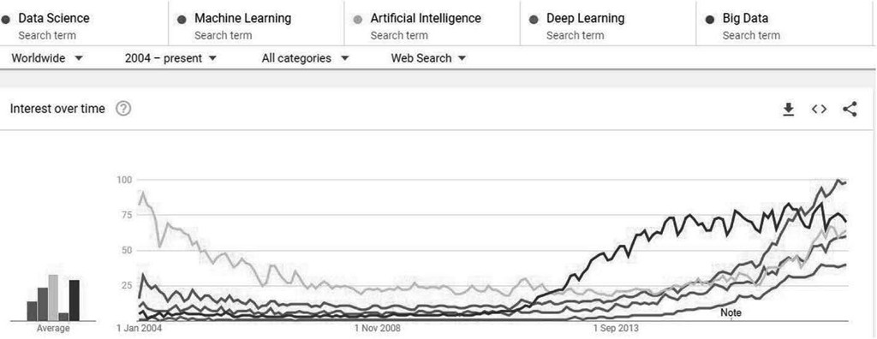
Figure 6.1: Google Trends, 2004–2018

In the midst of all this hype, there is a lot of confusion within this topic due to considerable noise in the literature. Many people get lost in the maze of terms like data science, machine learning, deep learning, and big data and do not know where to start. This chapter aims to clear up this confusion by providing a concise overview of data science and big data for business practitioners and discussing some commonly faced questions such as What are data science, big data, AI, machine learning? What are the applications of data science used in industry?

Moreover, what are the learnings and challenges of data science projects? We introduce some basic data science concepts and big data tools, and discuss the typical data science project lifecycle in an organization.

Applications of Data Science and Big Data
Data science and big data are firmly embedded today in a lot of products and services that meet our daily needs. Some common examples of everyday applications of data science and big data include
- Biometrics, such as face and fingerprint recognition, for unlocking phones using our faces or finger
- Matching drivers and commuters to simplify booking rides using taxi or other ride apps
- Recommendations for watching videos and shopping on e- commerce websites
- Targeting, such as product advertisements based on search engine history
The exciting part is that most of these products have come into existence within the past one to two decades and have become a part of our daily routines. Such widespread use of data science has arguably led tech companies such as Google, Facebook, Amazon, Netﬂix, and others to proliferate and disrupt existing businesses, and to create new products and experiences for their customers.
Now, let us illustrate in more detail some industry use cases where data science and big data are used and have proven to

be successful:
- Promotional emails and digital ads: On a typical day, people are contacted by several promotional email messages, SMS messages, or ads for things such as hotel discounts, airline vouchers, and shopping discounts. Sometimes, these promotional messages are targeted explicitly to specific customers. With the advent of the internet, companies have been gathering and storing extensive data related to their customers, such as customer demographics, past purchases, browsing patterns, and aﬄuence level. They use this data to understand the characteristics of their customers and build machine learning models based on those characteristics to identify the likelihood of a customer responding to a particular ad at a given moment. Depending on this likelihood, customers are contacted with the right offers and in many cases even personalized offers. This helps companies increase their sales by cross-selling and up- selling and also improve customer experience and engagement.
- Recommendation engines: Everyday, we come across various recommendation engines, such as for friends on Facebook, videos on YouTube, products on Amazon, and movies on Netﬂix. These systems show personalized offerings to people based on factors like their search histories and preferences. It is widely known that Amazon uses recommendation algorithms to personalize the shopping experience for each customer. Customers see recommended items that are based on their previous

browsing behavior, product ratings, similar product purchases and other factors.3 Along similar lines, Netﬂix recommends personalized content (movies and TV shows) based on a user’s viewing history and ratings, the viewing history of similar users, and so forth. Furthermore, these recommendations are diverse, include new releases, and adapt with time in response to changing user preferences.4
- Risk management: Banks and credit card companies have used credit scores to evaluate loan or credit card applications for many years. Credit scores typically indicate the risk level of a customer, such as the likelihood of a customer to default. The model takes into consideration several parameters, such as payment history, length of credit history, inquiries, and income, to predict a customer’s likelihood to default by comparing them to similar characteristics of other customers who have defaulted in the past.5
- Fraud detection: Fraud does not have a constant pattern.
Fraud detection model is an evolving process, and by investigating and ﬂagging more and more frequent cases, cases of fraud can be identified. In the case of credit card companies, investigating a large number of transactions one by one is not possible. Therefore, fraud detection models are used that can auto-approve legitimate transactions and raise alerts in case of any transactions that appear fraudulent. Events such as a sudden big purchase after many small purchases, purchases that do not fit the cardholder’s profile,

and unusual geographical locations can raise suspicion and block the transaction or card automatically.

What Is Data Science?
The term “data science” has been ﬂoating in various literature, journals and lecture notes for many years. In 1962, John Tukey, in his paper “The Future of Data Analysis,” pointed to the existence of an unrecognized “science” that dealt with the subject of learning from the data.6 Later in 2001, William S. Cleveland from Bell Labs proposed to expand the field of statistics to data analysis by emphasizing the importance of data preparation, computation, and presentation rather than statistical modeling.7 However, the term “data science” gained widespread popularity more recently in 2012 through a Harvard Business Review article “Data Scientist: The Sexiest Job of the 21st Century.”8 In academia or industry, there is no single approved definition of data science because it is a broad term encompassing many domains, which leads to different views and ambiguity.
However, in simple terms, one can understand data science as an interdisciplinary field that uses the concepts of statistics, mathematics, computer science, and domain expertise to extract meaningful insights from data that can generate some business value. A data scientist is someone who is a specialist in these three domains and extracts meaning from the data by performing data and statistical analysis; building and applying machine learning models and algorithms; and visualizing, summarizing and communicating the results. Figure 6.2

describes a data scientist with skills from these three domains. In reality, it is hard to find someone who is a perfect data scientist—highly skilled in all three domains. Therefore, organizations build data science teams with people of complementary skillsets.
The terms, “business analytics” and “data analytics” have been used popularly over the years and are often confused with data science. Overall, there is a blurred difference between analytics and data science, and therefore these terms are sometimes used interchangeably. Our interpretation of this blurred difference is that the role of a business/ data analyst involves using a lot of domain expertise and data analysis to generate insights from the data, whereas the role of a data scientist is slightly broader and includes machine learning modeling and programming. In many cases, the responsibilities of a data scientist also include data analysis, building models and developing those models into products or services.

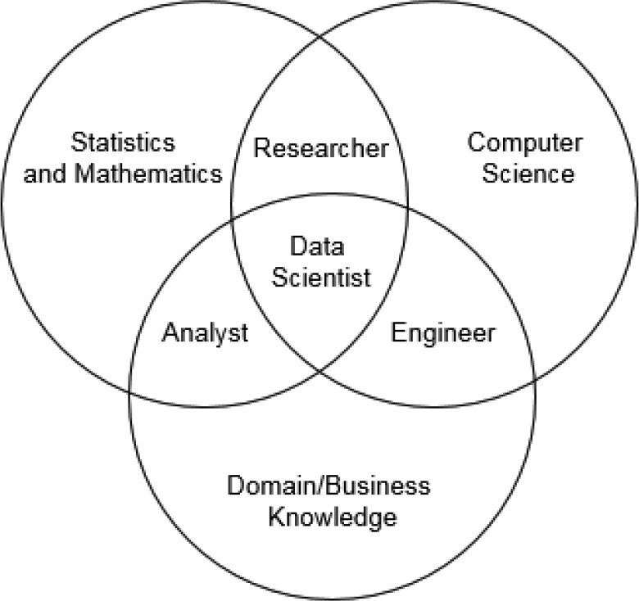

Source: Drew Conway’s Data Science Venn Diagram. [Online]. Available: htt p://drewconway.com/zia/2013/3/26/the-data-science-venn-diagramce: Figure 6.2: Data scientist Venn diagram

Machine Learning vs. Artificial Intelligence
Artificial intelligence (AI) is a field of computer science focused on making computers more intelligent so that they can imitate intelligent human behavior. AI is a medium to enable computers to learn and engage in human-like thought processes, such as learning, reasoning and self-correction. Traditionally, this involved hard-coding knowledge about the

world in the form of computer programs, but success was limited because most human knowledge grows with experiences and is subjective, intuitive and challenging to articulate using a set of rules. The introduction of machine learning enabled computers to learn real-world knowledge by identifying patterns from the data, self-correction from this learning process to enable decision making [9]. However, machine learning algorithms also suffered from a trade-off as their performance was dependent on how data was presented to them. Deep learning algorithms solved this problem by extracting information by itself. Deep learning is a particular type of machine learning that makes the computer learning more powerful, ﬂexible and abstract. The Venn diagram in Figu re 6.3 illustrates how these concepts are interrelated.

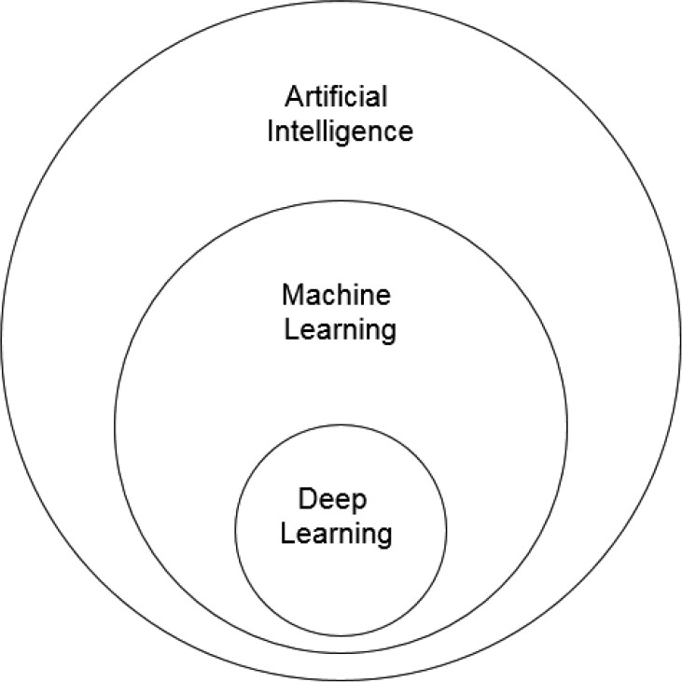

Source: Ian Goodfellow, Yoshua Bengio, Aaron Courville, Deep Learning, The MIT Press, 2016
Figure 6.3: AI, machine learning, and deep learning Venn diagram

What Data Science Is Not
AI, machine learning, and deep learning do not comprise a branch of data science. Rather, data science uses them to solve problems. Consider machine learning as a statistical toolkit that helps machines learn based on historical data and make predictions on the new data. On the other hand, data science is a broader term that includes the process for building this

machine learning model, including data collection, data processing, data analysis, data visualization, modeling, making predictions, and so forth.
Big data also is not a branch of data science. Data science can be used to solve problems using various types and sizes of datasets.

What Is Big Data?
The origin of the term “big data” is still ambiguous, but one of the early and popular definitions is that big data is the amount of data that traditional database software tools cannot manage and analyze due to the complexity and size.9 In simple terms, big data means large data, where large depends on the context and computational processing power. According to a report by IBM in 2013, about 2.5 quintillion bytes of data are created each day in the world.10 The pace of creation is only accelerating with the growth of internet access, increase in mobile usage, and IoT (internet of things) devices around the world. Data points are created in our daily activities, such as:
- Social media activity (Twitter tweets and messages; Facebook likes, shares and messages)
- Search engine activity (Google searches, creating web pages)
- Video streaming (watching or uploading videos on YouTube or Netﬂix)
- Payments (using credit cards, internet banking)
To make any use of this data, it needs to be captured. In the past, data storage was quite expensive and ineﬃcient, so

storing big datasets was a challenge. Now, there are better and more economical data storage solutions that make it easier to store and process the data.
IBM defined big data in association with four Vs: volume (size of the data), velocity (speed at which the data is created, stored, analyzed and visualized), variety (different data sources for structured and unstructured data), and veracity (trustworthiness of the data for any analysis in terms of accuracy and ambiguity, for example).11 Other researchers have defined big data as three Vs, six Vs and so on. Although there are several critiques of the V model, one thing is clear: there is a lot of data available that can be used for solving numerous business problems using data science.

Data Science and Big Data in Industry Practice
The key steps required in any data science project are shown in Figure 6.4. Regardless of the problem, any data science project can be deployed by following these steps. The multi-step lifecycle, from defining the problem to experimentation, is explained in this section. The big data technology stack used in this process, and also shown in Figure 6.4, is explained in the section “Big Data Technology Stack.”
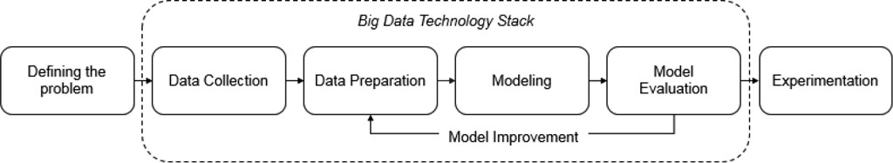
Figure 6.4: Data science project lifecycle

Step 1—Defining the Problem
Before starting to work on a data science task, the first step is to define the objective of the business problem clearly. This involves answering questions about different aspects of the problem, such as
- What is the business problem and how to translate it into a data science problem?
- What data is required for the problem and how to collect and to prepare it?
- What insights can be generated from the data and what machine learning/deep learning models can be useful for the problem?
- How to build and evaluate the model, define success (KPIs, metrics, and so on) for the solution of the problem?
- How to measure the impact of a machine learning model in the real world?
In practice, it is essential to simplify and structure the problem at this stage and precisely answer these questions. Depending on how the problem is structured at this step, the subsequent steps of data collection, data preparation modeling, model evaluation and experimentation can be different. This is illustrated using the following example over the course of the chapter:

Loan Delinquency Problem
A bank has disbursed personal loans to 800,000 existing savings/credit card customers over the last five years (2013–

2018). This loan scheme was expected to help customers and also bring additional revenue to the bank; however an investigation revealed that the scheme resulted in losses to the bank. The loan is supposed to be repaid in the form of monthly installments—where the installment amount and number of installments depend on the loan amount, loan tenure and agreed interest rate. When the bank is unable to debit any monthly installments for a month from the bank account, the loan is considered to be “delinquent.”
Since 2013, the delinquency rate is ~10 percent, or 1 out of
10 customers missed on their payment, but customers are charged with a hefty fee in case of any missed installment leading to dissatisfaction. The probability of missing payment is not yet considered in any risk management/account management decisions in the bank, which if considered can enhance the performance of savings/ credit card portfolio as well. Given this information, bank management has requested that its data science team identify customers who are most likely to miss payment of the loan installment in next three months so that these customers receive a telephone reminder. Bank management believes that such preventive action can keep some customers from missing payment and wants to test out this hypothesis. After its success is established, management would like to make telephone reminders a regular practice. It is also known that the bank’s call center’s capacity is calling only 30,000 customers per month. Therefore, it is essential to identify the right customers to call at the right time.

Given this problem statement, what are different ways to structure this problem into a data science problem?
- Objective: The problem involves finding top 30,000 customers with the highest likelihood to miss payment of their loan installment in the next three months so that they can receive telephone reminders. A few ways to approach this problem are
Approach 1: Identify customers whose account
balance falls below a certain amount, say, two to three times the amount of monthly loan installment. This approach might work well; however, it does not take into account the fluctuations in the account balance over the month. For example, some customers routinely pay their installments but have to wait for their pay to be deposited and might not need to be called. Can this be further improved?
Approach 2: Analyze the historical characteristics of customers who have missed payment of their loan installment in the past and understand the reasons behind it. For example, customers aged 30-40 years with income below $2500 per month are more likely to miss payment than other customers. Such insights can be used to generate rules to filter the right set of customers. Can these rules be further improved? Can these rules be made more robust?
Approach 3: Create a machine learning model using historical customer behavior and characteristics to predict a score for the likelihood to miss payment in

the next three months. This score would be specific to each customer and can change with time.
- Data collection and preparation: To proceed with any of these approaches, having data about customers who have missed a payment vs not missed any payment since 2013 can be useful. This data can be used to study the characteristics, such as customer account balance history, demographics, and loan details that can help to understand underlying reasons for missing payments. The sections “Step 2—Data Collection” and “Step 3—Data Preparation” describe how to gather the right data for the problem and various methods to collect and prepare such data.
- Modeling: In the case of Approach 3, this step can be used to gauge which machine learning models would be useful for the given problem. The “Modeling” section describes the types of machine learning models suitable for different problems and steps needed to build any model.
- Model evaluation: After the machine learning model is built, it is useful to evaluate its performance. This step is needed to gauge the performance of the model (how correctly the model can predict customers with high likelihood to miss payments in the next three months) before starting to call those customers.
- Experimentation: Although a model can help identify such customers who are likely to miss payment in next three months, it is necessary to test whether the model works in the real world. Experiments can be carried out to check model accuracy and the impact of calling. For example,

customers with a high likelihood to miss payment can be identified and either called or not called to answer these questions:
- Does calling customers with a high likelihood of delinquency actually prevent them from missing their payment?
- Do customers with a high likelihood of delinquency end up missing their payment when they are not called?
- Do customers with a high likelihood of delinquency end up missing their payment even after being called?
Answering such questions and analyzing the results can help to measure the success of the model in the real world. The “Step 5
—Experimentation” section describes how such experiments can be designed.

Step 2—Data Collection
After precisely defining the problem, the next step is to gather relevant data for that problem. This is done by following a systematic approach to gather various data from the variety of sources to get a complete picture of the problem. The different types of data are discussed below.
Based on the source, data can be mainly categorized into: primary data and secondary data:
- Primary data is the data that is gathered from the first-hand experiences of a researcher for a specific project. Usually, collecting primary data involves a lot of time, effort, and

cost. Examples of primary data include data collected using questionnaires, interviews, surveys, experiments, and so on.
- Secondary data is the data that was already collected and recorded in the past for a different problem. Usually, secondary data is readily available, so it is widely used in data science projects. Examples of secondary data include private datasets (for example, internal companies’ records), datasets for sale (such as those available through data aggregator companies), scraping websites, and public datasets (like government publications, books, journal articles, and so forth).
Care should be taken to ensure that data is relevant for the business problem and captures suﬃcient events of interest. Both primary and secondary data can be used for a data science problem, but in most cases, secondary data is used. This is because secondary data is cheap and provides a longer history, which includes more data points that could give more insights even though it is less accurate when compared to primary data. For the loan delinquency problem, secondary data from internal bank systems can be used containing details such as:
- Customer demographics (age, gender, income, location)
- Bank account details (number of accounts, tenure of the bank account, account status—active, inactive, or other)
- Account transaction details (types of transactions, amounts spend on different transactions)
- Loan details (loan status—delinquency, defaults, paid-up, or other; principal loan amount; outstanding loan amount, the total number of paid installments, date of delinquency)

- Other data, such as customer interaction details and website usage

Types of Data
Raw data (including primary and secondary data) is not always of great quality. The quality of data mainly depends on how the data is captured, what tools are used to capture it and what measures are used to ensure the right type. There are mostly three types in which data is captured, namely structured datasets, semi-structured datasets and unstructured datasets. Their differences are shown in Table 6.1.
Table 6.1: Differences between Structured, Semi-Structured and Unstructured Data
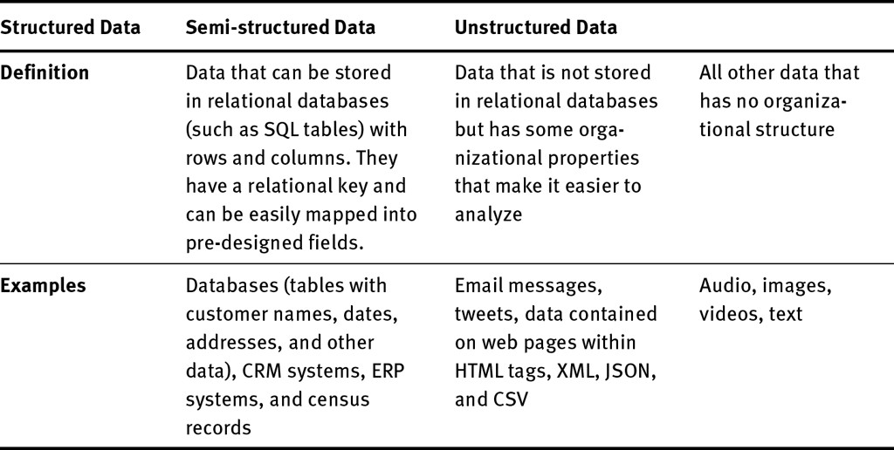

Traditionally, models have worked well on structured and semi- structured data but not so well on unstructured data (audio, images, and patterns in the text). But recent machine learning and deep learning algorithms are significantly better at

interpreting even unstructured data, which has led to many new exciting applications such as speech recognition, image recognition, and natural language processing on text. For the loan delinquency problem, all three types of data can be used depending on how the data is available in the bank systems. For example, both customer demographics recorded in structured databases and customer interactions recorded in the form of emails or voice recordings can be used.

Levels of Data
Structured data is captured at several levels. In this context, a “level” is the smallest unit of the data. For example, a transaction is the smallest level when money is transferred from one bank account to another. This transaction is captured as one row in the data. Similarly, a social security number uniquely represents a person, and one person will have consistent characteristics, such as gender and place of birth, associated with this social security number. Therefore, data can be captured at a person level using the social security number. On the other hand, for semi-structured and unstructured data, the levels may or may not be there. For example, unstructured text or images do have such levels. Table 6.2 illustrates different levels of data capture.
Table 6.2: Levels of Data

Level | Each Row Represents | Data gathered at each levels
Event | One event | Data for each event, like the time of a banking transaction

Entity One user, product family, or other such entity
For example, age, gender, demographics, aggregation of event level data to user level—customer’s month-end ledger balance

Segment One segment For example, a list of cities with average
income more than $30,000

Data with more granularity captures more information. For example, a customer’s daily banking transaction amounts provide more information about the customer’s transaction behavior than the total transaction amount for the bank. Therefore, in the loan delinquency problem, event or user level data would be more useful than segment level.

Step 3—Data Preparation
After gathering data from various sources, the next step is to process and transform this data into a useable form for the analysis. Often data is collected from various sources, so it is untidy—has inconsistent data types, useful columns spread across multiple files, etc. Data preparation involves steps such as performing quality checks, filtering, and aggregating, joining, concatenating different datasets, creating features so that it can be used to generate some meaningful insights and further used for modeling tasks. The first step of data preparation is performing data quality checks. Data collected in the real world for practical purposes is usually of poor quality—data has incorrectly captured information, missing values, duplicate records, and so forth. Therefore, it is essential to perform

quality checks (QCs) on the data and address issues before proceeding.

Data Quality Checks
The ideal method for performing data quality checks is to check every record against the source system. But if there is a large number of records across many files, such a method can be cumbersome. Therefore, some pragmatic means are needed to gauge the quality of the data. Some of the typical measures used to perform data quality checks include the following:12
- Completeness: Check whether all intended datasets and data items (fields, values) are captured. Compare the numbers of rows, columns, and fields; the size of the data at the source data; and the available data to ensure completeness.
- Accuracy: Secondary data is not as accurate as primary data, but realistically, it should be checked to determine how well the data represents real-world observations and events. Therefore, check whether the data was captured accurately:
By reconciling it with third-party source data that is
trustworthy or confirming insights with the business teams.
By checking for abnormal values in data, such as values that are too high or too low, or missing or incorrect values (numerical or categorical). If abnormal values account for too many of those in a column, then the result of data analysis can be biased. Thus, all abnormal values should be treated.

- Uniqueness: Check whether all records are uniquely captured; that is, there is no duplicate information. Identify the unique keys of the data (for example, bank account number or customer ID) and check if the dataset is unique across these keys. For example—if same customer across one customer ID has duplicate records then de-duplicate the data by either removing duplicate rows or aggregating them to the customer ID level.
- Consistency: Check whether the data is consistent with different representations of the same information across multiple datasets; that is, there is no difference between two representations of the same data. This can be done by analyzing patterns and verifying insights from the data fields. For example—dataset is inconsistent if number of registered bank customers is less than number of active bank customers.
- Validity: Check whether data conforms to the standard data definitions, such as data types, size and format. This can be done by analyzing the data types of fields in the source data and available data.

Exploratory Data Analysis
After completing the quality checks on the data, the next step is to perform exploratory data analysis (EDA), or descriptive analysis. EDA is an approach to analyze the data by summarizing its main characteristics into summary statistics and graphical representations. For example, we might carry out a univariate analysis (such as frequency or central tendency—

mean, median, and mode) on different variables, and perform a bivariate analysis, such as analyzing variables with each other and analyzing variables with the target variable. In the context of machine learning, the variable that is predicted is called the output variable or business outcome or target variable. In the loan delinquency problem, the target variable has two outcomes: delinquent (customers who miss payment of loan installment in the next three months) and non-delinquent (customers do not miss payment of loan installment in the next three months). This is illustrated in Figure 6.5.
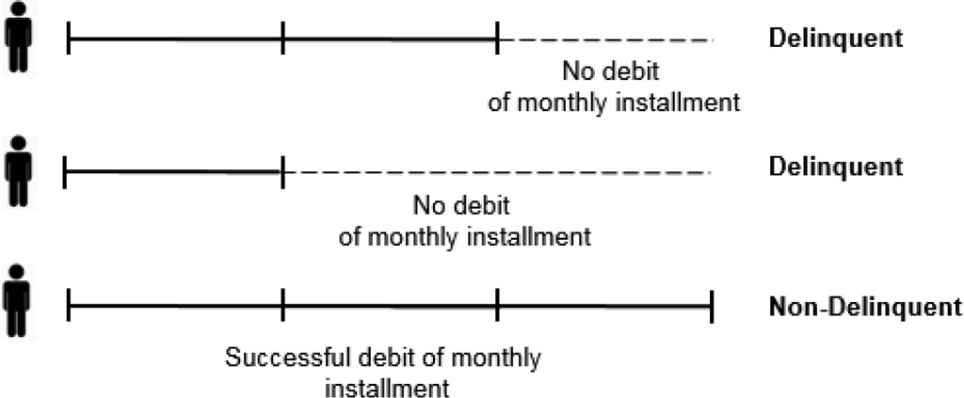
Figure 6.5: Target creation

At this step, it is also important to realize that dataset should be filtered for appropriate customer cohort i.e. customers with that specific personal loan. EDA can help generate insights by analyzing different variables for the customers of interest. In this problem, variables such as the customer’s month-end ledger balance, age, account tenure, and so on, can also be useful to look into. EDA could help us analyze account balance with respect to the target variable to tell whether there is any

account balance pattern that suggests whether a customer is likely to miss payment. Overall, the objective of EDA is to try and find these specific patterns from the data. For example, Tab le 6.3 suggests that customers with lower month-end ledger balances are more likely to miss on payments than other customers as delinquency rate increases with the decrease in balance. On the other hand, different age buckets do not indicate any significant difference in delinquency rates.
Table 6.3: Exploratory Data Analysis Using Tables

Month-end Ledger Balance ($) | Delinquency Rate
Less than 2500 | 15%
2500–5000 | 8%
5000–7500 | 9%
7500–10000 | 7%
Greater than 10000 | 5%
Age Buckets (Years) | Delinquency Rate
Under 25 | 10%
25–50 | 9.5%
50–75 | 9%
Over 75 | 11%

There are several approaches to performing an exploratory data analysis:
- Tables: Summarize the data in the form of tables (as in Table 6.3) and generate insights.

- Visualization: Visualize these variables (as in Figure 6.6) in graphical representations like histograms, pie-charts, or bar charts.
- Correlations: Find correlations of these variables with each other and with the target variable (in this case it’s delinquent, Yes or No).
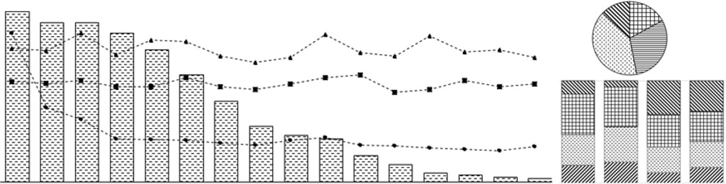
Figure 6.6: Exploratory data analysis

Feature Engineering
After completing an EDA, the next step is to represent raw data in a format that captures these insights in the form that can be fed to a machine learning model. Such transformation/engineering of variables into the formats suitable for the machine learning model is called feature engineering, and transformed variables are called features. Machine learning models take these features as input and learn from them to predict the output. Feature engineering is one of the crucial steps to build any machine learning model because good features improve model performance by producing high- quality output. In fact, a simple model with good features may outperform a complex model with bad features. The idea of feature engineering is to create more features using the data and present them in a simpler way, which can inﬂuence the

output of your model. Often, feature engineering becomes a necessity as a machine learning model needs data to be presented in a certain way that it understands. Some models are more appropriate for the certain type of features; therefore, feature engineering involves creating the most appropriate features given the data, model, and problem.
In the loan delinquency problem, if the selected model only accepts numerical values, then any feature that is not numeric would need to be either dropped or transformed into a numeric. For example, in Table 6.4, a categorical feature “highest education level” with four categories—Ph.D., Bachelors, Masters, and High School—would need to be either dropped or transformed to a numeric field that captures the essence of these four categories. At the end, when all features are combined, the resulting feature table would be like Table 6. 4.
Table 6.4: Feature Table
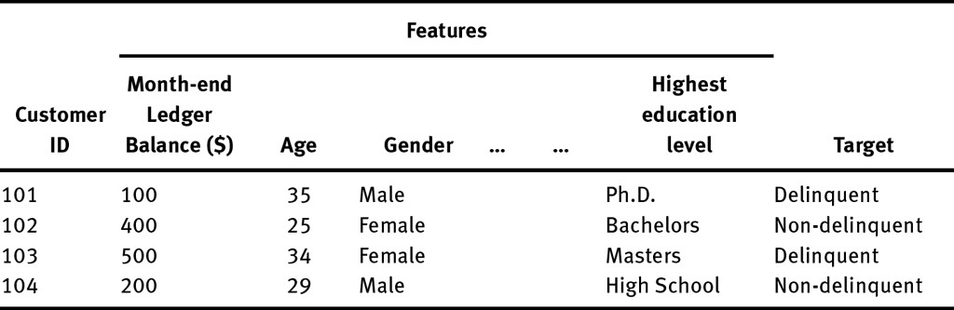

There is no right or wrong way to perform feature engineering, but Table 6.5 shows some basic techniques which can be used for structured data (example—tabular data) and unstructured

data (example—text data). Note feature engineering for other unstructured data such as audios, videos and images are beyond the scope of this discussion:
Table 6.5: Feature Engineering Techniques

Type of Data Technique Description and Examples*

Structured data (for example, tabular data)
Quantization/ binning

Normalization/ scaling
Continuous numerical variables can be quantized into fixed categories (binary or multiple groups). For example, “age” can be quantized, corresponding to different life stages, into 0-25 years, 25-50 years, 50-75 years, and 75 years or older.
Features with drastically different scales can be appropriately scaled before modeling. For example, if income ranges from $2,000 to $50,000 and age ranges from 15 years to 100 years, then income should be appropriately scaled to a hundredth scale as age or vice versa.

New features New features can be created from existing features to extract more information. This step should be done by using inputs of business stakeholders. For example, monthly income and expenses can be used to create a new feature “monthly savings” to identify customers who are not saving enough and may need a personal loan.
Cleaning text Preprocessing and filtering can eliminate useless data that adds noise. For example,

Unstructured data (for example,
text data) Feature extraction
- Remove web page tags and attributes and special characters such as punctuations, alphanumeric characters, and symbols.
- Convert words to a single case (lower or upper), remove stop words, frequent words and rare words, and remove prefixes and suffixes.
Numerical features are extracted from clean, processed/ text by using words as keys or features and different word frequencies as values. Popular feature extraction techniques include bag-of-words (BoW) and term frequency-inverse document frequency (TF-IDF).

*Note: Zheng, A. and Casari, A. (2018) Feature Engineering for Machine Learning, California: O’Reilly.

Feature Matrix
After creating the features, the next step is to combine all the engineered features from structured and unstructured data and target column(s) into one table/matrix called feature matrix. A feature table from Table 6.4 would transform into a feature matrix as in Table 6.6 after feature engineering. Observe that a variable such as gender is converted into columns “Gender_Male” and “Gender_Female” with binary values (1 or 0); education” is converted as into 4 education level columns; unstructured text such as “car” is used to create Bag-of-words features like “BOW_car” and TF-IDF feature like “TF-IDF_car,”

etc. Now, this feature matrix can be easily fed into a machine learning model.
Table 6.6: Feature Matrix
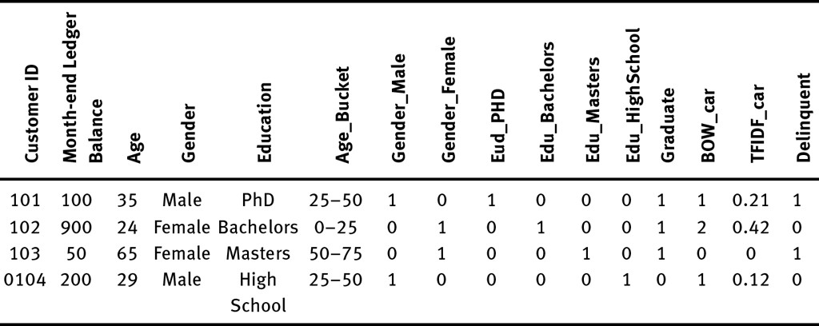

Note that this is just one illustration. Feature engineering steps largely depend on the type of problem, data and machine learning model one intends to use. For example, unsupervised learning problems do not have a target variable; therefore, the feature matrix would not have a target column. This is further described in the next section. Also, not all features in the feature matrix will be used in the model. Some categorical features, such as gender and education, which have already been converted into columns, can be dropped. Depending on preference, one can choose to merge features differently, but creating such a matrix makes it more eﬃcient to experiment with feature selection in modeling.

Step 4—Modeling

After data collection and data preparation, the next step is to build the right model for the problem. This section provides a broad introduction to different machine learning algorithms with emphasis on how to build a model with the problem in mind. Broadly, machine learning models can be classified into two categories, supervised and unsupervised learning:
– Supervised learning involves building models to predict a target using different features. Often supervised machine learning tasks include building models to estimate future predictions using historical data, often called predictive models. Typical predictive model problems include classification and regression:
Classification is a problem in which the target variable
is qualitative (two or more categories). The loan delinquency problem is an example of the binary classification problem where two prediction classes are “Delinquent” and “Non-delinquent.” Other examples include predicting whether an email is spam and handwritten character recognition.
Regression is a problem in which the target variable is a quantitative value (numeric), such as predicting loan default amount for each customer. Typical examples include sales forecasting, price prediction, and loan default amount prediction.
– Unsupervised learning involves learning from the input data without any target. In this case, the algorithm tries to use an underlying structure of the data to find useful associations and patterns. Most of the raw data in the world does not

have a well-defined target variable; therefore, unsupervised learning techniques are applicable to a lot of problems. Typical problems include clustering and association:
Clustering is a problem of dividing the data into
similar homogenous groups. Typical examples of clustering include identifying similar customers based on purchase behavior (customer segmentation), similar documents, and clustering similar news articles.
Association is a problem of finding associations between different variables that can describe characteristics of the data. Popular examples include market basket analysis to find bundled products as they are mostly bought together—mobile phones with covers, milk and butter, beer and diaper.

Choice of Models
Several machine learning models have been developed that cater to different realworld problems. To apply a machine learning model, it is essential to identify the type of task: supervised learning (classification, regression) and unsupervised learning (clustering, association). Table 6.7 summarizes a few modeling algorithms.
Table 6.7: Supervised and Unsupervised Learning Models

Type of Learning Models

Supervised learning Naive Bayes

Linear models, such as linear or logistic regression Decision tree
K-nearest neighbors (k-NN) Bagging, such as random forest
Boosting, such as generalized boosting machine Support vector machines (SVMs)
Neural networks

Unsupervised learning Clustering, such as k-means, hierarchical, or DBScan
Associations, such as a priori

Each of these models has their uses, advantages, and disadvantages. One of the popular algorithms is linear regression or logistic regression when there is a linear association of features with the target, that is, target linearly increases or decreases with a change in features. In many industrial applications, linear models are adopted as they are simple and quite interpretable. However, these models can have limitations in terms of predictive power as real-world associations between features and target may be nonlinear. In such cases, nonlinear models, such as decision trees, bagging, boosting, neural networks, and support vector machines, should be used.

Model Building
A model is just a mathematical function that can be used to represent the relation between features in the data. Practically, there is no perfect model. One can only attempt to create good models that can meet business needs. Building a model can be

an iterative process: one may try several models, a different combination of features, and different modeling techniques before finding one that satisfies the requirement.
There are several ways to build a supervised machine learning model, but typically, models include training, validation, and testing, as reﬂected in the following standard steps:
- Split the data randomly into two sets, namely training data
and validation data. A good starting point is a ratio of 80/20 (80 percent training data and 20 percent validation data).
- Training data is used to train or teach the model to predict the target using the features. At this step, an appropriate model should be chosen based on the learning task.
- Validation data is used to evaluate the performance of the model. At this step, errors in the model should be analyzed and used to make some adjustments to the models, such as tuning the model, selecting features, and making other decisions regarding the learning algorithm.
- Lastly, the final model obtained after training and validation is applied to an entirely new dataset called the test dataset to which the model has not previously been exposed. The performance on the test set indicates the actual performance of the final model, or what performance to expect when using the model in the real world.
Please note that the preceding steps are not fixed and can vary depending on the problem, data, and approach. There are many different ways to split the data into training and validation data, create test sets, and perform additional steps to ensure model

stability. Figure 6.7 summarizes the dataset splitting and modeling approach.
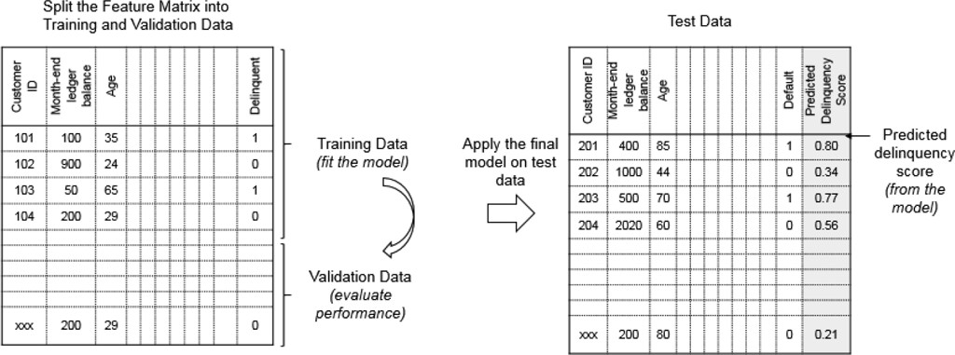
Figure 6.7: The modeling process

Building an unsupervised learning model is often more challenging than supervised learning model. Unsupervised learning models do not have a target; therefore, there is no way to check whether the model is performing well or poorly because there is no clear right answer. Often performance needs to be evaluated using past experience and domain knowledge. This makes model building quite a subjective process.

Model Evaluation
As described above, there is no perfect model. Every model suffers from some errors. The process to evaluate the prediction errors of a machine learning model is called error analysis. Ideally, each prediction output of a model should be checked to examine the error and understand its underlying cause. However, manually doing these checks is time-consuming, especially with large datasets. Therefore, evaluation metrics are

needed to gauge the overall prediction performance of the model.
Machine learning offers a large choice of evaluation metrics depending on the task involved. For classification tasks, comparisons can be made between correct and wrong predictions of the true target by using a commonly used error matrix called a confusion matrix. For regression tasks, errors can be measured between the predicted target and true target. Table 6.8 shows some of the commonly used evaluation metrics for classification and regression tasks.
Table 6.8: Evaluation Metrics for Different Tasks

Task Evaluation Metrics

Classification Accuracy, recall, precision, F-measure, AUC ROC Regression Root mean squared error (RMSE), adjusted R-squared

Error Analysis
To evaluate the performance of any machine learning model, errors need to be measured and analyzed. There are primarily three sources of errors in any machine learning model, irreducible errors, bias, and variance.
An irreducible error (Bayes error or unavoidable bias) is an error that cannot be reduced regardless of the modeling algorithm. This type of error can be introduced by problem objective, noise and errors in the data capture; unknown variables that can inﬂuence each other and the target; and other factor. No model is perfect, so an expectation of 100- percent accuracy is simply unrealistic. Therefore, the objective

of modeling is to create a model that comes as close as possible to the desired performance.13
Bias is another error which is introduced due to erroneous assumptions in the model while variance is an error due to variability in the model predictions. In simple terms, this concept is explained in the bulls-eye diagram in Figure 6.8.14 The center of the concentric circle represents a perfect model which predicts all targets correctly, and each dot represents one model. Sometimes the model prediction is close to the ideal model prediction while sometimes it is far off.

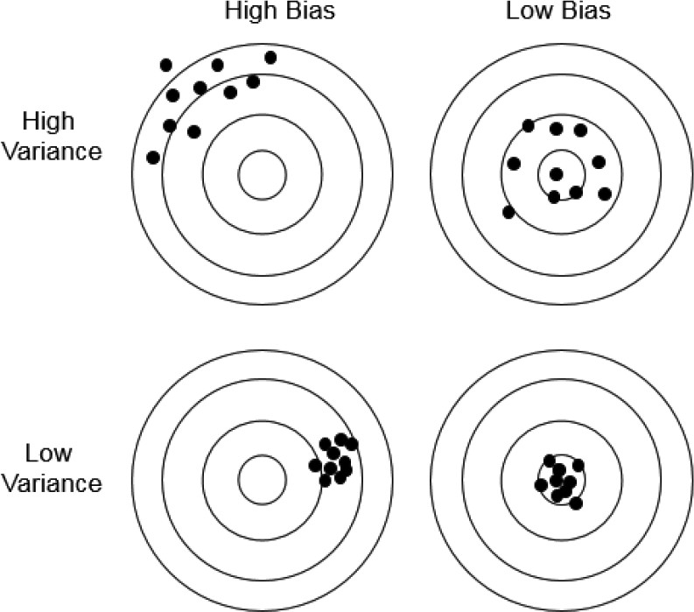

Source: Fortmann-Roe, Scott, Understanding the Bias-Variance Tradeoff, htt p://scott.fortmann-roe.com/docs/BiasVariance.html
Figure 6.8: Understanding bias and variance

Whereas bias measures how far off these model predictions are from the perfect model, variance measures how far off the model predictions are from each other. Typically, bias and variance have competing properties, and improving one usually compromises the other. That is, a low-bias model has high variance, and a high-bias model has low variance.15 As seen in Figure 6.9, with the increase in model complexity model bias decreases but variance increases. The art is to find a model

with the right level of complexity that has low bias and low variance.16
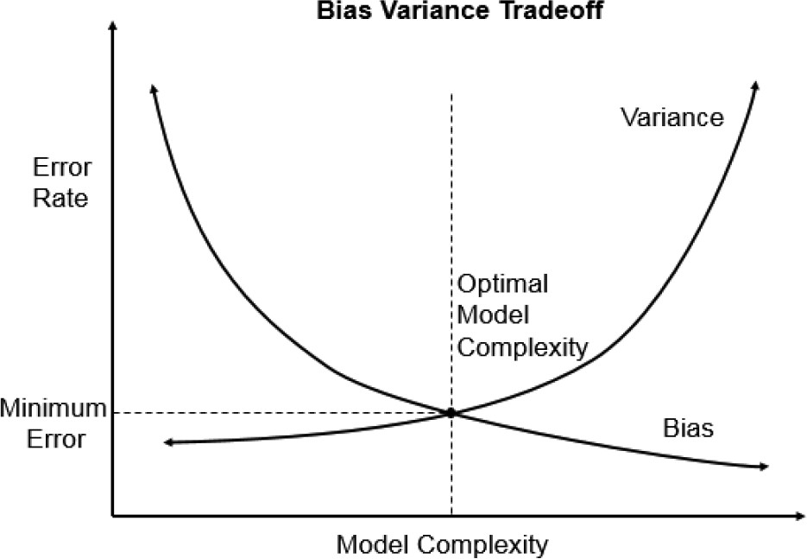
Source: Fortmann-Roe, Scott, Understanding the Bias-Variance Tradeoff, htt p://scott.fortmann-roe.com/docs/BiasVariance.html
Figure 6.9: The bias vs variance tradeoff in a model

Suppose, after several modeling iterations on the loan delinquency problem, different error rates are calculated on training and validation data. Out of all the customers in the training dataset, the model is correctly able to predict 90 percent of customers if they would become delinquent or not. Then the error rate of the model is 10 percent, which includes irreducible errors, bias, and variances. After calculating errors on different iterations of the models, efforts should be made to reduce these errors as described in the following:

- A model with high bias is underfitting. That is, the model has barely learned on the training set to even perform well on validation and test sets. A good way to address this problem is by increasing the model complexity, such as by adding more features.
- A model with high variance is overfitting. That is, the model has tried to capture too much information from the training set and failed to generalize on new data. A good way to address this problem is by adding more training data.
Ideally, a model with low bias and low bias is a good model which should be finally selected.

Model Improvement
After evaluating the errors, the next step is to improve the performance of the model further to create a final model. Note that model improvement is also an iterative process and the modeling process goes through the steps of data collection, data preparation, modeling and evaluation again and again. There is no completely right or wrong way to do this, but the following points should be kept in mind while experimenting with model improvement:
- Add external data, such as census data or credit scores, to create new features.
- Add more and more features but at the same time include features that inﬂuence the target.
- Have training, validation and test sets with sizes suﬃcient to have statistically significant data points to learn training and validation error rates.

- Use modeling technique suitable for the problem.
- Control for model complexity and generalization by reducing the number of features.

Step 5—Experimentation
Model evaluation techniques only help to evaluate the theoretical performance of the model on the validation and test sets. But theoretical performance does not guarantee the success of the model in real-world. For example, in the loan delinquency problem, customers identified as high likelihood to miss payment of loan installment would need some action such as reminder calls in order to prevent them missing their payment. A campaign can be designed to make preventive calls to all such customers. In practice, there can be lot of operational issues (e.g. capacity of call center, script designing and training to call center agents, IT issues in implementing the new process, data privacy/ information security especially in case of outsourced call center, etc.), in executing such a campaign. Therefore, it is essential to conduct such campaigns on small scale i.e. on small customer base, learn and address these issues before implementing such campaigns regularly for all customers. In addition to this, testing the model on a small base can also help in observing quantitative benefits from this exercise and qualitative feedback from customers.
Experiments should be designed in such campaigns in order to test out different hypothesis and quantify the actual impact of the models and know whether it meets the desired

expectations. There are many different ways to design an experiment, but the following are important general steps:
- Define a relevant success metric that meets the business objective. Examples of such metrics are conversion rate, customer retention rate, saving costs, or crosssell rate.
- Divide the population randomly into groups to measure the performance improvement of the model. One of the ways is to design an A/ B test with two groups:
  - A test group, on which the output of the model is tested
  - A control group that does not use model output
- Execute the experiment and measure the success metric for the test and control groups
In the loan delinquency problem, an A/ B test can be designed to measure (a) the impact of then model (do the customers identified as having a high likelihood to miss payment actually end up missing payment) and (b) the impact of preventive reminder calls to customers using the call center (does call center calling prevent customers from missing payment).
Following the preceding steps, an experiment can be designed as follows (see Figure 6.10):
- The success metric can be defined as the “delinquency rate”: the percentage of customers who missed out their payment during the three months of campaign duration
- Divide the population into test and control groups in equal proportions with enough samples to measure the performance between the groups:

  - Test group: The customers identified by the model as having a high likelihood to miss payment. Furthermore, divide the test group into two more groups: Group A, the customers who are called by the call center, and Group B, the customers who are not called.
  - Control group: The customers who are randomly selected or selected using some existing rules (that is, without applying the model). Similarly, divide the control groups into two more groups: Group C, the customers who are called, and Group D, the customers who are not called.
- An experiment can be conducted to measure the delinquency rate success metric over these four groups to quantify the real impact of the model based on the real impact of preventive calling. The call center can actively call customers under Group A and Group C, while customers under Group B and Group D can be left without calling.
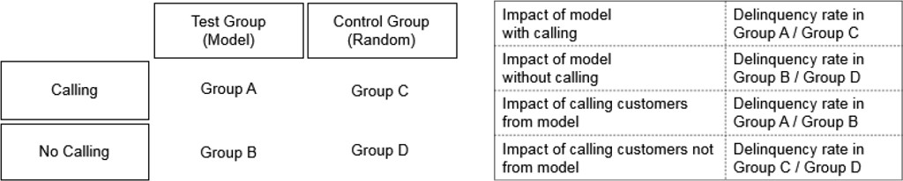
Figure 6.10: The A/B test design

After all the customers are successfully contacted, the delinquency rate of these groups should be measured over three months to observe whether the model and preventive

calling helped. Ideally, if the model and preventive calling has a positive impact, the following should be true:
- The delinquency rate of Group B should be more than that of Group D. This would mean that the model is correctly able to identify customers who would miss payment: customers in Group B (who have a high likelihood to miss payment as per the model) end up missing payment more than the randomly selected customers in Group D.
- The delinquency rate of Group A should be less than that of Group B. This would mean that preventive calling leads to a lower delinquency rate in the customers identified by the model as having a high likelihood to miss payment. This is because customers in both Group A and Group B are identified from the model, but only Group A customers are called. Similarly, the delinquency rate of Group C should also be less than that of Group D.
- The delinquency rate of Group A also can be compared with the delinquency rate of Group C to measure the impact of the model on the customers who are called. Note that the impact of preventive calling can have different effects on customers from Group A (high likelihood to miss payment) and Group C (random customers). For example, preventive calling can remind customers and eventually reduce the delinquency rate, or it may have no impact at all as those customers might have already decided to miss payment.
These measurements can easily help quantify the success of the model and success of preventive calling. Additionally, these impacts also can be estimated in terms of dollar value to

quantify the business impact. Once the success of the model and preventive calling is established from this experiment, bank management can implement such campaigns regularly. This can be done by preparing such list of customers with high likelihood to miss payment and conduct preventive calling every month.

Big Data Technology Stack
This section describes the big data technology stack, which forms a backbone for any data science project. As defined in the data science lifecycle (refer to Figure 6.3), different tools are needed for collecting the data, preparing and manipulating the data, building machine learning models and evaluating the performance of these models.
Figure 6.11 describes popular tools used for data ingestion and data storage (under data collection) and data preparation, modeling and evaluation (under data processing). Note that only open source software option licensed under Apache Software Foundation are described here because they are widely used across the industry and have good open source community support. But generally, companies use open source or commercial tools based on their needs.

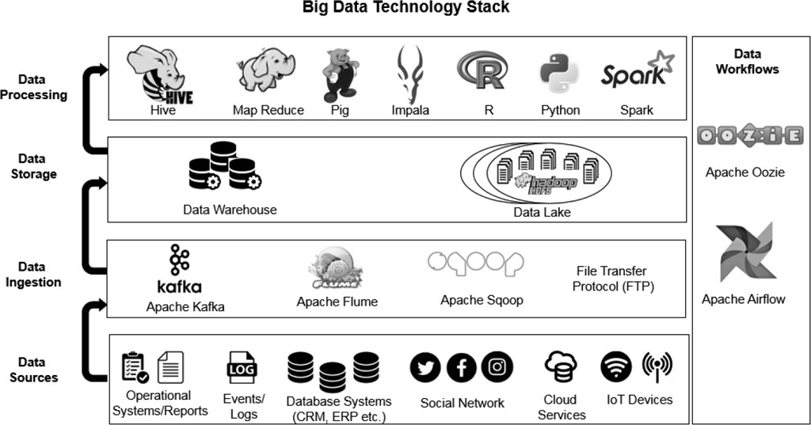

Figure 6.11: The big data technology stack

Data Collection Toolkit
As explained in the preceding section, data collection involves ingesting data in different formats and from different sources. Depending on the volume, velocity, variety and veracity of data, different tools can be used. For example, a number of tweets about one topic on Twitter could be in the range of a few thousand per second, whereas the number of transactions on a stock exchange can be in the range of few hundred thousand per second or even more. Depending on the high volume and velocity of data from a stock, different tools may be required for ingesting and storing the data.
Broadly, data collection involves these two steps, data ingestion
and data storage:
- Data ingestion: Data ingestion involves ingesting or importing the data from different sources. The ingestion can

happen in batches or real time:
Batches: When data is ingested in batches, it is imported in discrete chunks at periodic intervals of time. The batch can run daily, weekly, or monthly depending on the requirement (for example, sales reporting or financial consolidation). The advantage of batch processing is that it allows for some high level of transformation on the data before storing.
Real time: When data is ingested in real time, it is imported from the source with a short execution time, providing near-instantaneous output. Real-time ingestion does not allow complex data transformation; therefore, it is mainly used in processes where data is needed quickly for real-time actions or decisions. Some examples where real-time ingestion is required include high-frequency trading, sentiment analysis on social media, and IoT (internet of things) data capture.

Data Ingestion Tools
There are many open source tools available for ingesting the data in real-time and batches. Some of these tools are the following:
Apache Kafka is a streaming platform used for handling real-time data feeds.
Apache Flume is used for efficiently collecting, aggregating, and moving bulk streaming data.
Apache Sqoop is used for efficiently transferring data from a relational database to Hadoop HDFS.

(HDFS is a popular data storage system used by Hadoop architecture. It is just a type of distributed file system, or a system that stores a copy of files stored across multiple computers.) Source: Apache Software Foundation. [Online]. Available: http://www.apac he.org
In cases where only data transfer is needed, then FTP can be used. The transfer can be from the data source to the landing zone (temporary storage location) or from landing zone to a database, data warehouse or data lake (permanent storage location).
FTP (file transfer protocol) is a network protocol used to transfer files between a client and a server. It enables easy data transfer across the network. For more secure file access, transfer and management, SFTP (SSH file transfer protocol) is used.
Source: The TCP/IP Guide. [Online]. Available: http://tcpipguide.com/

- Data storage: Data storage involves storing all the data in a single storage place, which provides robustness, security, and ﬂexibility. There are many data storage solutions over the cloud and on-premises that can be used according to need. Two popular ones are data warehouses and data lakes:
A data warehouse is a centralized repository that
stores data from multiple sources and transforms it into a standard format for efficient storage, querying and analysis. In data warehouses, data is stored in RDBMSs (relational database management systems) in the form of tables, in which the table structure/schema is predefined. This ensures that the data organization is subject to database rules to ensure accuracy, credibility, and integrity. Due to the

data warehouses rules, bad quality data is either rejected or treated according to special rules.
A data lake is a system that gives flexibility to store data in any format (relational, non-relational, and so on). The principle of data lake is “Store first, process later,” or have single storage for all of the data that anyone in an organization might need to analyze. Data is kept in its raw form and transformed only when it is ready to be used. In contrast to a data warehouse, a data lake does not need a data table structure/schema before storage. These applications make data lakes an ideal choice to store all data of a company as it does not require any business specification before storage and saves a lot of time and effort.

Data Lakes with Apache Hadoop HDFS
Data lakes are commonly constructed with the Hadoop architecture because Hadoop provides a collection of open source software libraries that can efficiently store and process big datasets. Some advantages of using HDFS:
- HDFS is better than traditional distributed file systems as it is highly fault-tolerant. It can prevent data loss in case of system failure as a copy of files is stored across multiple computers.
- It can store massive datasets with easy access.
- It can break down data into separate pieces and do parallel processing.
- It has a low cost compared to a traditional data storage system.
Source: Apache Hadoop. [Online]. Available: http://www.apache.org

Data Processing Toolkit
After storing the data, the next step is to process and transform it into a useable form for modeling. The toolkit described in this section covers tools usually used for data preparation, modeling and evaluation. Often data is collected from various sources, so it is untidy. That is, it has inconsistent data types, useful columns spread across multiple files, and other unstructured characteristics. Data processing ensures that this data is organized so that is easy to retrieve whenever needed. This step is also called data transformation as it involves steps such as changing the data types, filtering, aggregating, joining or concatenating different datasets. The transformed datasets can then be used to generate some meaningful insights or business intelligence reports.
Traditionally, companies have followed an ETL (extract, transform and load) approach, which involves performing such transformations before loading data into the database. But many times, the entire transformation process can be cumbersome and significantly reduce the volume of the data that can be stored. With the availability of cheap and scalable data storage, such as data lakes, companies are gradually moving from ETL to an ELT (extract, load and transform) model where transformation can happen after storing the data. The advantage is that all the data can be stored first and transformed later according to need. However, in practice, companies are neither completely ETL (as they need to store more and more data) nor completely ELT (as storing entire raw

data may consume a lot of disk space which can be unnecessary and add to the cost).

Data Processing Tools
Some of the data processing tools described here can be used for data preparation, building machine learning models and even perform model evaluations. Data processing for small datasets can be handled by commonly used spreadsheet tools, but processing of bigger datasets requires tools like R, Python, SQL, Hive, Impala, and Pig. The following are some of the commonly used data processing tools: R and Python are open-source programming languages widely used in data science for data processing and modeling.
SQL is a programming language widely used for querying and managing data in relational databases. Hadoop MapReduce is a programming model in Hadoop used for parallel processing of large datasets in a distributed manner.
Apache Hive is a data warehouse built on Hadoop for data processing, summarization, querying, and analysis using a SQL-like language called Hive QL (HQL). Pig is a high-level scripting language for performing data analysis on top of Hadoop.
Impala is another query engine built on top of Hadoop in which querying is faster than Hive.
Apache Spark is a processing framework similar to but much faster than MapReduce. It supports various tools for different purposes, such as Spark SQL for structured datasets, Spark Streaming for data streaming, MLlib for machine learning, and Apache Storm for real-time computation.
Source: Apache Software Foundation. [Online]. Available: http://www.apache.org

Data Workflow Toolkit

Given the standard steps of data ingestion, data transfer, data storage and data processing, there are two ways these processes can be operationalized: either by manually executing these steps, or using data workﬂows that can carry out these processes automatically or semi-automatically. It is diﬃcult to manually perform all of these tasks eﬃciently, accurately and quickly every time new data is received. Therefore, data workﬂows/pipelines are created to automate these processes.

Workflow Tools
Some of the popular open source data workflow tools include the following:
Apache Oozie is used to automate the entire data ingestion, transfer, storage, and processing process and schedule these processes as jobs. Apache Oozie is quite useful as it can fully integrate with the Apache Hadoop and supports Hadoop jobs for Apache MapReduce, Pig, Hive, and Sqoop. In addition to that, complex data transformations that need complex scheduling can be managed by creating sub-workflows.
Apache Airflow is another open source tool managing complex computational workflows and data processing pipelines. Overall, Airflow supports connectors to most of the cloud service providers, and it has a better UI, which can help you visualize your pipeline’s dependencies and see how they progress.
Source: Apache Software Foundation. [Online]. Available: http://www.apache.org

In addition to the open source solutions for the big data technology stack, there is a mix of good commercial cloud platform solutions (standalone or built on top of these open source frameworks) offered by leading companies. A few such solutions are AWS (Amazon Web Services), Microsoft Azure, and Google Cloud Platform. The advantages of using these

commercial solutions is that they can provide on-demand cloud computing solutions with software, databases, computing power and services on a paid subscription basis.

Challenges and Lessons from Data Science Projects
Data science is a rapidly evolving field with continuous research and development of new algorithms, big data and analytics tools, and products using machine learning. Yet, many organizations have started adopting data science only quite recently. Due to this limited experience, there are several challenges that companies face when they start working on data science. These challenges can be unique to the company, team, project or even the model, but broadly, most of the challenges are similar across the industry (based on the maturity of the data science practice). The following are the typical challenges faced while working on data science projects: – Data platform (legacy systems): Many companies that are new to data science (but have been in existence for several decades) have legacy systems. It is diﬃcult to connect these legacy systems seamlessly to data lakes, for example. It is complex to implement a new algorithm and way to feed data back to the legacy system for operations teams that need to
use them in decision making.
- Data quality and data dictionaries: In most companies, raw data is dirty (missing, inaccurate, duplicate, misleading, and non-integrated), and data dictionaries are incomplete or absent. This poses a significant challenge to data scientists’ productivity as they need to spend a lot of time in

understanding the data and perform a lot of quality checks. And many times incorrect data can lead to erroneous results.
- Data privacy and lack of data access: In many projects, data is not available, or not available on time, due to data privacy issues. To resolve these issues, an upfront assessment of data privacy should be done at the scoping phase itself, and appropriate measures should be taken to address the issues. In some cases, a project may have to discontinue due to unresolved issues.
- Ethical Issues: Many times, data science projects involve working with sensitive data such as race, gender, religion, national origin, and medical history, and we should be careful to use only data that is allowed by rules and regulations. Some of the variables, even though allowed by the regulations, might introduce discrimination (or marginalize certain sections of the society). Organizations must take extra care to ensure that algorithms do not create discrimination and are used in ethical ways.
- Lack of project sponsorships: Many companies do not focus on investing appropriately in data science projects. This is due to a couple reasons:
First, data science projects usually have a high setup
cost (cost of resources and big data tools). Also, management often does not fully understand the potential benefits of data science project.
Second, management usually underestimates the complexity associated with implementing a successful

experiment in business operations. A lot of projects fail when implemented at scale in an organization even after success during experimentation. This is due to challenges associated with integrating data science models with legacy systems, and due to the complexity associated with change management, as business processes need to be updated and teams have to accept new ways of working.
- Expectation management: It is diﬃcult to manage expectations about the impact of data science projects with management. It can only provide you a limited boost in business or reduce ineﬃciencies. Remember that data science is not magic! The benefit of a data science project also may not immediately quantifiable when used to develop a data-driven approach for business, automatic processing, data-driven decision making for business transformation and change management, training existing employees with data science skills, and so forth, but can eliminate future problems and help create a data-driven culture. This should also be explained to management to set the right expectations.
- Focus on wrong problems: The lack of clear direction, unclear problem statements, and unclear execution plans can cause data science projects to fail. For example— building a cool product without any business utility is likely to fail, as in cases when the product or model was created by data geeks without involving business teams.

Conclusion
The field of data science and big data is very broad. The aim of this chapter was to provide a high-level overview of the data science and big data analytics field and explain some key concepts. To master this field and develop proficiency to apply these learnings in the real world, one must go through further readings and practice on real-world problems (under the supervision of an experienced data scientist) or on open data science competitions. Moreover, the field is rapidly evolving and therefore continuous learning is required to keep up to date about the developments.
In order to gain further knowledge about this subject, the following are some good resources:
- An Introduction to Statistical Learning with Applications in R by Gareth James, Daniela Witten, Trevor Hastie and Robert Tibshirani
- Machine Learning: A Probabilistic Perspective by Kevin Murphy
- Machine Learning with R by Brett Lantz
- Doing Data Science by Cathy O’Neil, Rachel Schutt
- Deep Learning by Aaron Courville, Ian Goodfellow, and Yoshua Bengio
- Mining of Massive Datasets by Jure Leskovec, Anand Rajaraman, Jeff Ullman
- Coursera online course: Machine Learning by Andrew Ng

Endnotes

- Data source: Google Trends (https://www.google.com/trends).
- Ng, Andrew (2018) Machine Learning Yearning—Technical Strategy for AI Engineers in the Era of Deep Learning, Unpublished book, www.mlyearning.org
- Linden, Greg, Smith, Brent, York, Jeremy (2003) Amazon.com “Recommendations: Item-to-Item Collaborative Filtering, IEEE Internet Computing,” v. 7, n. 1, pp. 76–80, January 2003. doi>10.1109/MIC.2003.1167344
- Gomez-Uribe, Carlos A. and Hunt, Neil (2016) “The Netﬂix Recommender System: Algorithms, Business Value, and Innovation, ACM Transactions on Management Information Systems (TMIS),” v. 6, n. 4, pp. 1–19, January 2016.
- Khandani, A. E., Kim, A. J., and Lo, A. W. (2010) “Consumer credit-risk models via machine learning algorithms.” Journal of Banking & Finance, v 34, pp. 2767–2787.
- Tukey, John W. (1962) “The Future of Data Analysis.” Ann. Math. Statist. v. 33, n. 1,
pp. 1–67. doi:10.1214/aoms/1177704711
- Cleveland, William S. (2001) “Data Science: an action plan for expanding the technical areas of the field of statistics.” International Statistical Review, v. 69, n. 1, pp. 21–26.
- Davenport, Thomas & J Patil, D. (2012) “Data Scientist: The Sexiest Job of the 21st Century.” Harvard Business Review. v. 90, pp. 70–76, 128.
- Manyika, J., Chui, M., Brown, B., Bughin, J. et al. (2011) Big data: The next frontier for innovation, competition, and productivity, McKinsey Global Institute working paper. www.mckinsey.com
- Jacobson, Ralph (2013) “2.5 quintillion bytes of data created every day. How does CPG & Retail manage it?” (IBM, April 24, 2013) [Online]. Available: https://www.ibm.co m/blogs/insights-on-business/consumer-products/2-5-quintillion-bytes-of-datacreated- every-day-how-does-cpg-retail-manage-it/
- IBM Corporation (2016), “The Four V’s of Big Data,” 2016. [Online]. Available: htt p://www.ibmbigdatahub.com/infographic/four-vs-bigdata

- Pipino, L.L., Lee, Y.W., and Wang, R.Y. (2002) “Data quality assessment.”
Communications of the ACM, v. 45, n. 4, pp. 211–218.
- Ng, Machine Learning Yearning, op.cit.
- Fortmann-Roe, Scott Understanding the Bias-Variance Tradeoff http://scott.fortma nn-roe.com/docs/BiasVariance.html
- Ibid.
- James, G., Witten, D., Hastie, T., Tibshirani, R. (2013) An Introduction to Statistical Learning with Applications in R, 2013, Springer Science and Business Media, New York.
We would like to thank AXA for providing an intellectual environment where we could devote time to write this chapter and receive feedback and guidance from colleagues. This chapter is written to provide a high-level introduction and motivation to readers on data science and big data. Most of what we discuss here has already been said in many books, research papers, blog posts, mailing lists, and so on. The further reading suggestions and references at the end of the chapter are great sources if you want to learn any specific area in more depth.
Ankur Agrawal is a seasoned actuarial, analytics professional heading AXA Data and Tech Innovation Asia lab. Objective of the lab is to drive AXA towards a tech-led company by leveraging data and emerging technologies at scale which have the potential to disrupt the current insurance business model and provide opportunities to shape future businesses. In his last role with AXA Business Services in India, he was a member of Exec team responsible for managing a team of over 200+ professionals

supporting 20+ AXA entities across life, health and P&C actuarial, data science, and research areas spanning North America, Europe and Asia region. Prior to that, he has held various leadership positions in actuarial areas in direct companies as well as consulting firms across life, health and P&C actuarial, operational areas spanning North America, Europe and Asia region. Ankur is a qualified actuary from Institute and Faculty of Actuaries UK and Institute of Actuaries of India and also holds a Bachelor of Technology, Mechanical from Indian Institute of Technology, Delhi.
Siddhant Tiwari is a data science professional working as a senior data scientist at AXA Data and Tech Innovation Asia lab. His role at lab involves executing high-impact data science projects for AXA entities and supporting them in their data transformation journey. He is experienced in leading data science projects involving opportunity assessments, customer acquisitions, cross-selling and up-selling, product recommendations, customer retention, risk management and fraud. Previously, at ZS Associates, he consulted various Fortune
500 pharmaceutical clients in devising sales and marketing strategies to improve brand positioning in the market using data analytics. He holds a BE Hons. in Electrical and Electronics from BITS Pilani, India and MSc. in Business Analytics from National University of Singapore.
OceanofPDF.com

